**Instruction: Answer all questions. Write your answer in the table located at the final page of this document.**

Continuing from lab 4, so far we have created the main page where users could enter their height and weight and the app could calculate and classify the users based on their BMI category. For this lab, we are going to add some navigation that allows the user to move from one page to another.

iOS

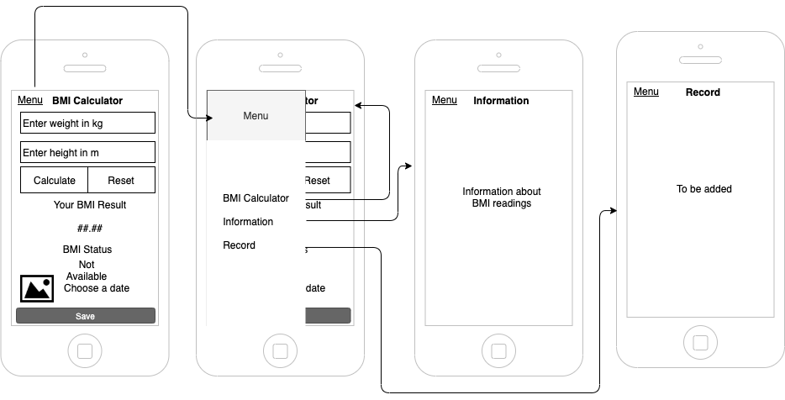

Android

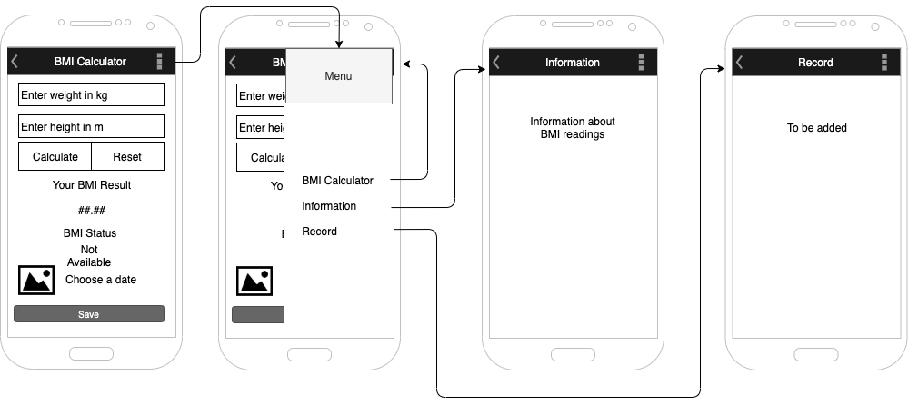

**Activity 1 – Create Master Detail Page**

You need to screen capture each of the following highlighted activities.

1. **Right click** on BMICalculator project on the solution explorer.
2. Add -> new item

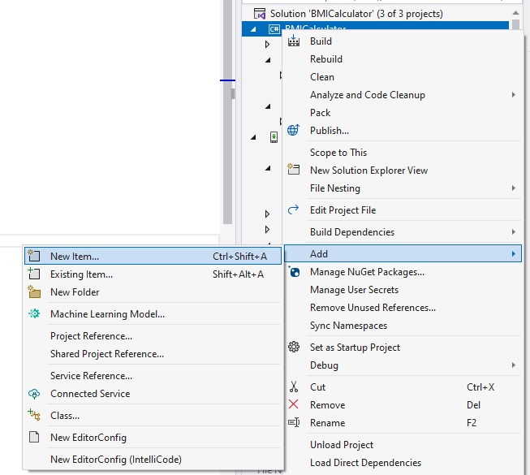

1. Choose Flyout Page. Set the name as **MasterDetailPageBmi**

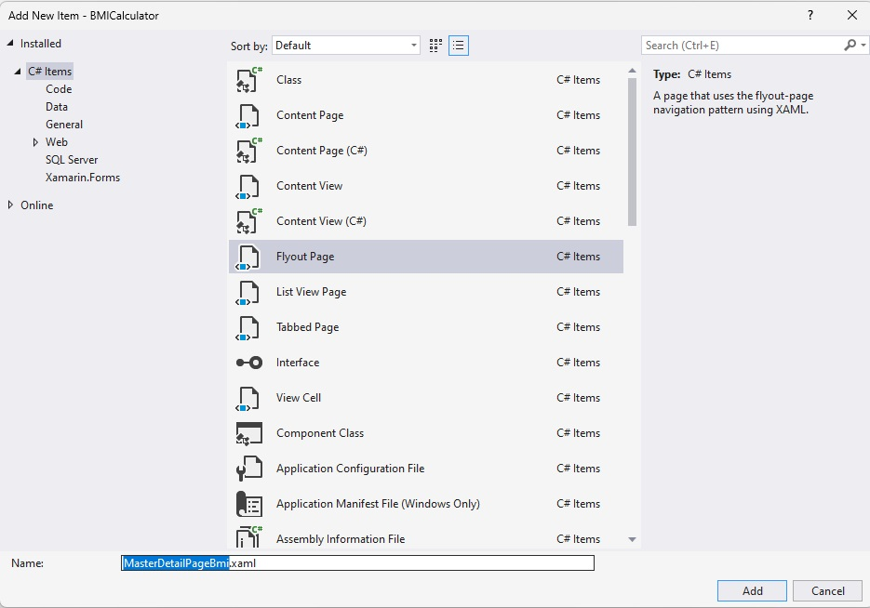

1. Then, you will see there are 4 newly added items on the Solution Explorer

1. Expand App.xaml
2. Double click on App.xaml.cs
3. Comment the following code using // to disable it

|  |
| --- |
| //MainPage = new NavigationPage(new MainPage()); |

1. We want to change the code so that it loads the MasterDetailPage right after the splash screen. Add the following line of codes after the one that we just disabled

|  |
| --- |
| MainPage = new MasterDetailPageBmi(); |

1. Expand MasterDetailPageBmi.xaml
2. Double click MasterDetailPageBmi.xaml.cs
3. We want to add the list into the Master Page and we want to navigate the Main Page to be loaded. Add the following highlighted code into the source code at line 19

|  |
| --- |
| public MasterDetailPageBmi()  {  InitializeComponent();  FlyoutPage.ListView.ItemSelected += ListView_ItemSelected;  Detail = new NavigationPage(new MainPage());  } |

1. Run the application on Android/iOS. Try clicking on the hamburger icon. Screen capture the result on Android/iOS.

**Activity 2 – Customize the Master Detail Page**

1. Next we want to change so that Menu is displayed instead of AppName on the title. Expand MasterDetailPageBmiFlyout.xaml.
2. Change the attribute Title of ContentPage from AppName to Menu.
3. Find ListView.Header. Change the Label text from AppName to Menu.

|  |
| --- |
| <Label  Grid.Column="1"  Grid.Row="2"  Text="Menu"  Style="{DynamicResource SubtitleStyle}"/> |

1. Change the Background color to Grey, #B8B8B8 or Gray

|  |
| --- |
| <Grid BackgroundColor="#B8B8B8">  <Grid.ColumnDefinitions>  <ColumnDefinition Width="10"/>  <ColumnDefinition Width="*"/>  <ColumnDefinition Width="10"/>  </Grid.ColumnDefinitions> |

1. Open MasterDetailPageBmiFlyout.xaml.cs. (At line 36, 37 and 38) Change the Title for “Page 1” into “BMI Calculator”, “Page 2” into “Information”, and “Page 3” into “Record”. Remove the lines for page 4 and 5.
2. Run the application on Android/iOS. Try to click the hamburger icon. Screen capture the result on Android/iOS. (Do not click on any of the menu item yet as we have no assigned any pages yet to the menu item)

**Activity 3 – Link the MenuList to a Page**

1. From the MenuItem list, we want to navigate to another page. Still working on MasterDetailPageBmiFlyout.xaml.cs. Add TargetType to the MenuItem list.

|  |
| --- |
| public MasterDetailPageBmiFlyoutViewModel()  {  MenuItems = new ObservableCollection<MasterDetailPageBmiFlyoutMenuItem>(new[]  {  new MasterDetailPageBmiFlyoutMenuItem { Id = 0, Title = "BMI Calculator", TargetType=typeof(MainPage) },  new MasterDetailPageBmiFlyoutMenuItem { Id = 1, Title = "Information" },  new MasterDetailPageBmiFlyoutMenuItem { Id = 2, Title = "Record" },  });  } |

**Save your work.**

We will need to create a page for Information and Record before we can do the navigation for the Information and Record menu item. We will do just that in Activity 4.

**Activity 4 – Add a New Page for Information and Record**

1. Add a new page for Information. Right click on BMICalculator project on the solution explorer. Add new item-> Choose ContentPage->Set the name to Information. Add.

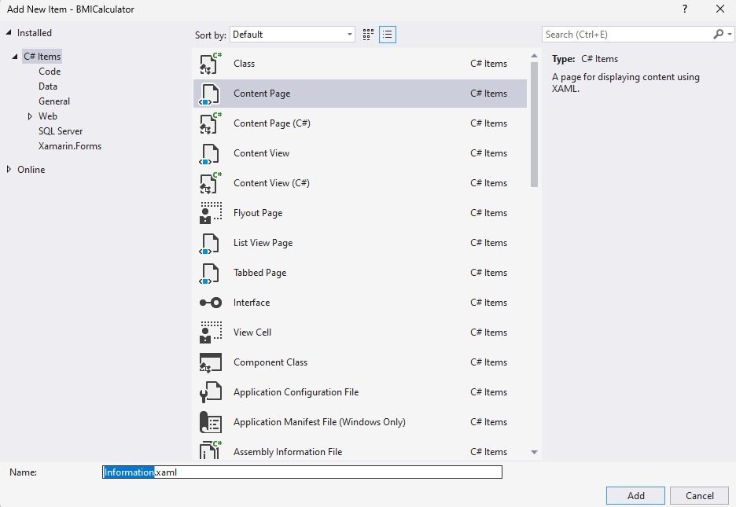

1. You will find 2 files created, Information.xaml and Information.xaml.cs.
2. Open Information.xaml. Insert <ContentPage.Content> </ContentPage.Content> with the following code.

|  |
| --- |
| <StackLayout>  <Label  Text="Underweight (below 18.5)"  HorizontalTextAlignment="Center"  VerticalTextAlignment="Center"  />  <Label  Text="Normal (18.5 - below 25)"  HorizontalTextAlignment="Center"  VerticalTextAlignment="Center"  />  </StackLayout> |

1. Continue to fill in the page with information on Overweight and Obese. **Save**
2. Add the TargetType in the MenuList for the Information page. Open MasterDetailPageBmiFlyout.xaml.cs.

|  |
| --- |
| MenuItems = new ObservableCollection<MasterDetailPageBmiFlyoutMenuItem>(new[]  {  new MasterDetailPageBmiFlyoutMenuItem { Id = 0, Title = "BMI Calculator", TargetType=typeof(MainPage) },  new MasterDetailPageBmiFlyoutMenuItem { Id = 1, Title = "Information", TargetType=typeof(Information) },  new MasterDetailPageBmiFlyoutMenuItem { Id = 2, Title = "Record" },  }); |

1. Add a new page for Record. Right click on BMICalculator project on the solution explorer. Add new item-> Choose ContentPage->Set the name to Record. Add.
2. You will find 2 files created, Record.xaml and Record.xaml.cs.
3. Open Record.xaml. Insert <ContentPage.Content> </ContentPage.Content> with the following code.

|  |
| --- |
| <StackLayout HorizontalOptions="Fill" >  <Label  Text="To be added"  HorizontalTextAlignment="Center"  VerticalTextAlignment="Center"  />    </StackLayout> |

1. Add the TargetType in the MenuList for the Record page. Open MasterDetailPageBmiFlyout.xaml.cs.

|  |
| --- |
| MenuItems = new ObservableCollection<MasterDetailPageBmiFlyoutMenuItem>(new[]  {  new MasterDetailPageBmiFlyoutMenuItem { Id = 0, Title = "BMI Calculator", TargetType=typeof(MainPage) },  new MasterDetailPageBmiFlyoutMenuItem { Id = 1, Title = "Information", TargetType=typeof(Information) },  new MasterDetailPageBmiFlyoutMenuItem { Id = 2, Title = "Record", TargetType=typeof(Record) },  }); |

Now all your menu item should be working and clickable.

1. Run the application on Android/iOS. Click Information on the menu. Screen capture the result on Android/iOS.
2. Run the application on Android/iOS. Click Record on the menu. Screen capture the result on Android/iOS.

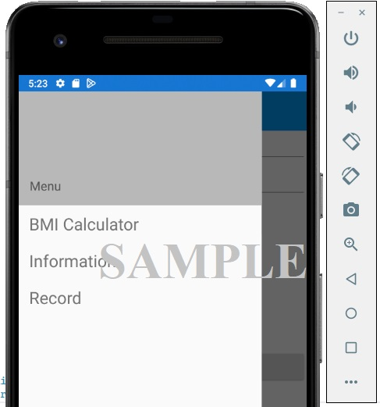

**Instruction: Write your answer in the specified column given.**

|  |  |  |
| --- | --- | --- |
| **QUESTION** | **MARKS** | **ANSWER** |
| **Activity 1** |  |  |
| Run the application on Android/iOS. Try to click the hamburger icon. Screen capture the result on Android/iOS. | 5 |  |
| **Activity 2** |  |  |
| Run the application on Android/iOS. Try to click the hamburger icon. Screen capture the result on Android/iOS. | 5 |  |
| **Activity 3** |  |  |
| **Activity 4** |  |  |
| Run the application on Android/iOS. Click Information. Screen capture the result on Android/iOS. | 5 |  |
| Run the application on Android/iOS. Click Record. Screen capture the result on Android/iOS. | 5 |  |
| **TOTAL** | **20** |  |

|  |
| --- |
| Rename your word document file to:  Lab 5 <studentID>.docx before the submission.  Submission type: Online |